*Group Members:*

Reema Albouainain (202103056)  
Fatima Almohannadi (202002307)  
Shatha Alhazbi (202108114)

*Web development fundamentals project*

***PHASE 1***

**Table of Contents**

**Phase 1**

|  |  |
| --- | --- |
| **Titles** | **Page no.** |
| Introduction | 2 |
| Github Link | 2 |
| Class Diagram | 2 |
| Project Structure | 3 |
| Screen Shots | 4- |

**Introduction:**

This report documents the development of an e-commerce platform specifically designed for the vibrant art community. The platform connects artists, acting as sellers, with art enthusiasts as customers. We focused on building a visually appealing user interface (UI), a robust Web API, and reliable data storage in JSON files to facilitate seamless art discovery and transactions. This report will detail the design, implementation, testing phases, and individual team member contributions. We also made sure each type of user (admin, customer, seller) navigates the website in a different manner

**Github repo link:**

**Class diagram:**

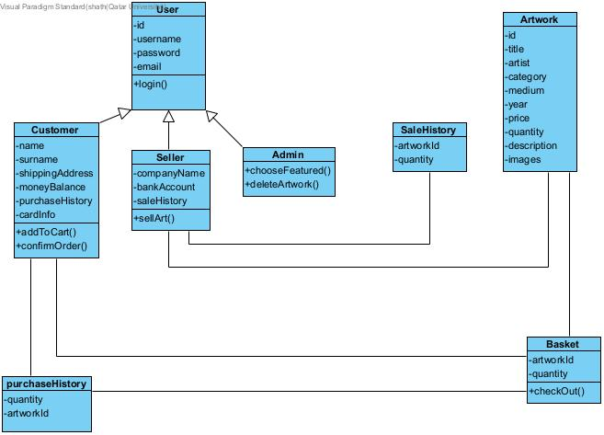

**Project Structure/Info**

* CSS: This is where we’ve meticulously organized our styling. You'll find separate CSS files like accountInfo.css, basket.css, and checkout.css to keep the design modular. Each file targets specific sections of the app, while styles.css handles the core, overall look and feel. It's the foundation for consistent styling across all the pages.
* js: This folder houses the heart of the app's interactivity. Files like basket.js, checkout.js, and login.js handle all the dynamic stuff – adding items to the cart, smooth checkout processes, and secure user logins. We designed these scripts to work seamlessly for a great user experience.
* db: This is our data powerhouse. Instead of a complex database setup, We chose simple and streamlined JSON files. artwork.json stores all the details on the masterpieces featured on the site, while users.json manages user information.
* Our Data is then loaded and saved in the local storage (temporarily for this phase)
* images: A picture's worth a thousand words, right? This folder holds all the high-quality images that visually enhance the app.
* HTML Files: The visuals! the foundation of each webpage. They define the structure, the headlines, the paragraphs... basically, the content you see. Of course, they link to our fancy CSS and powerful JavaScript to make the app come alive!

**Main page** 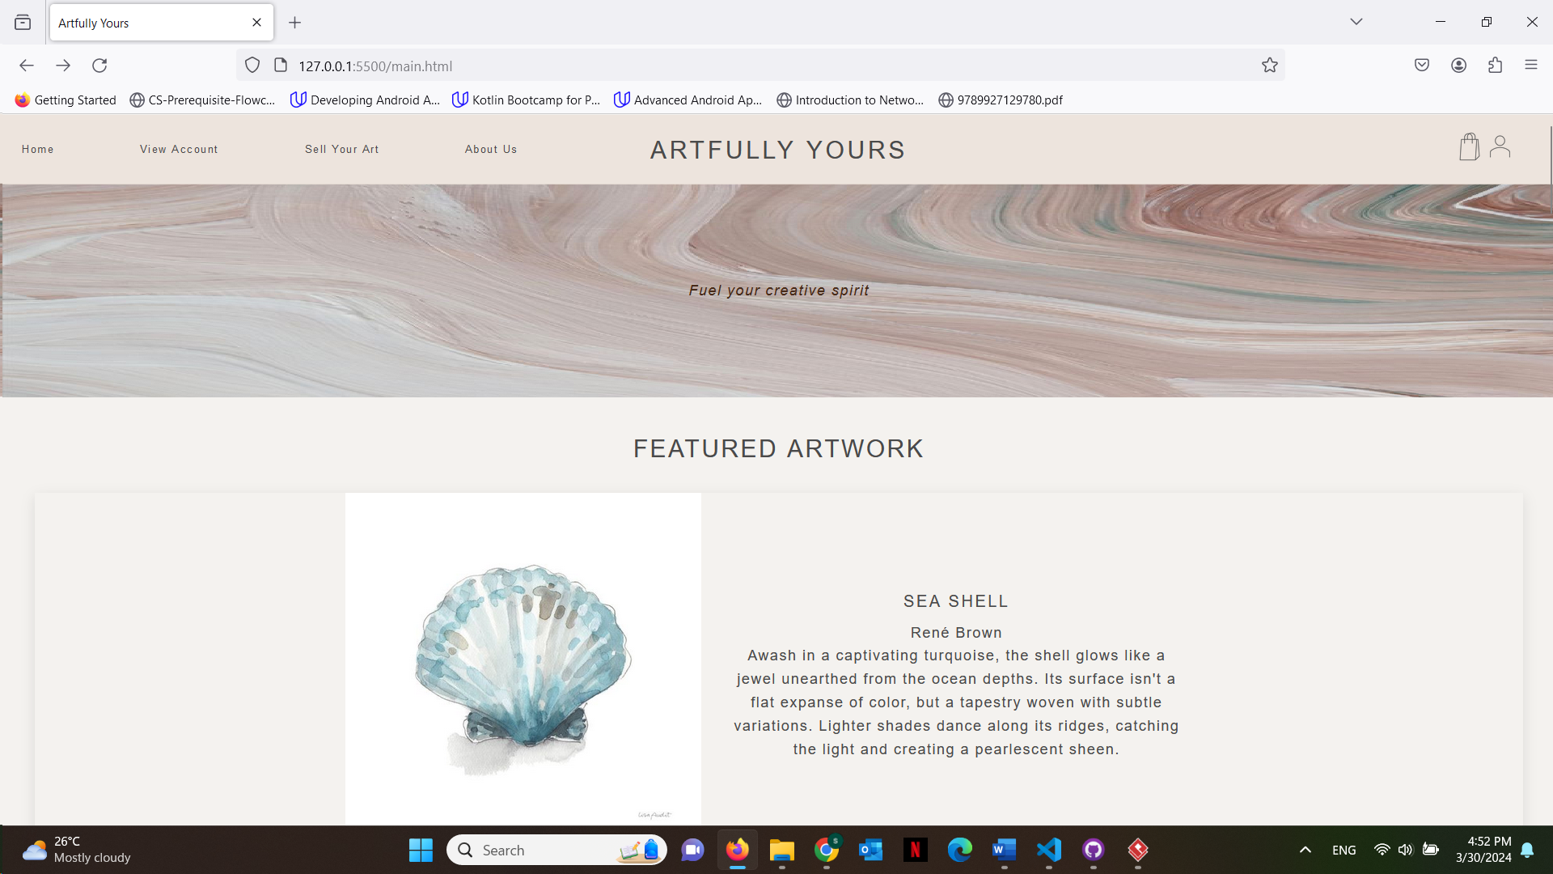

**Login page (logging in as admin user now)**

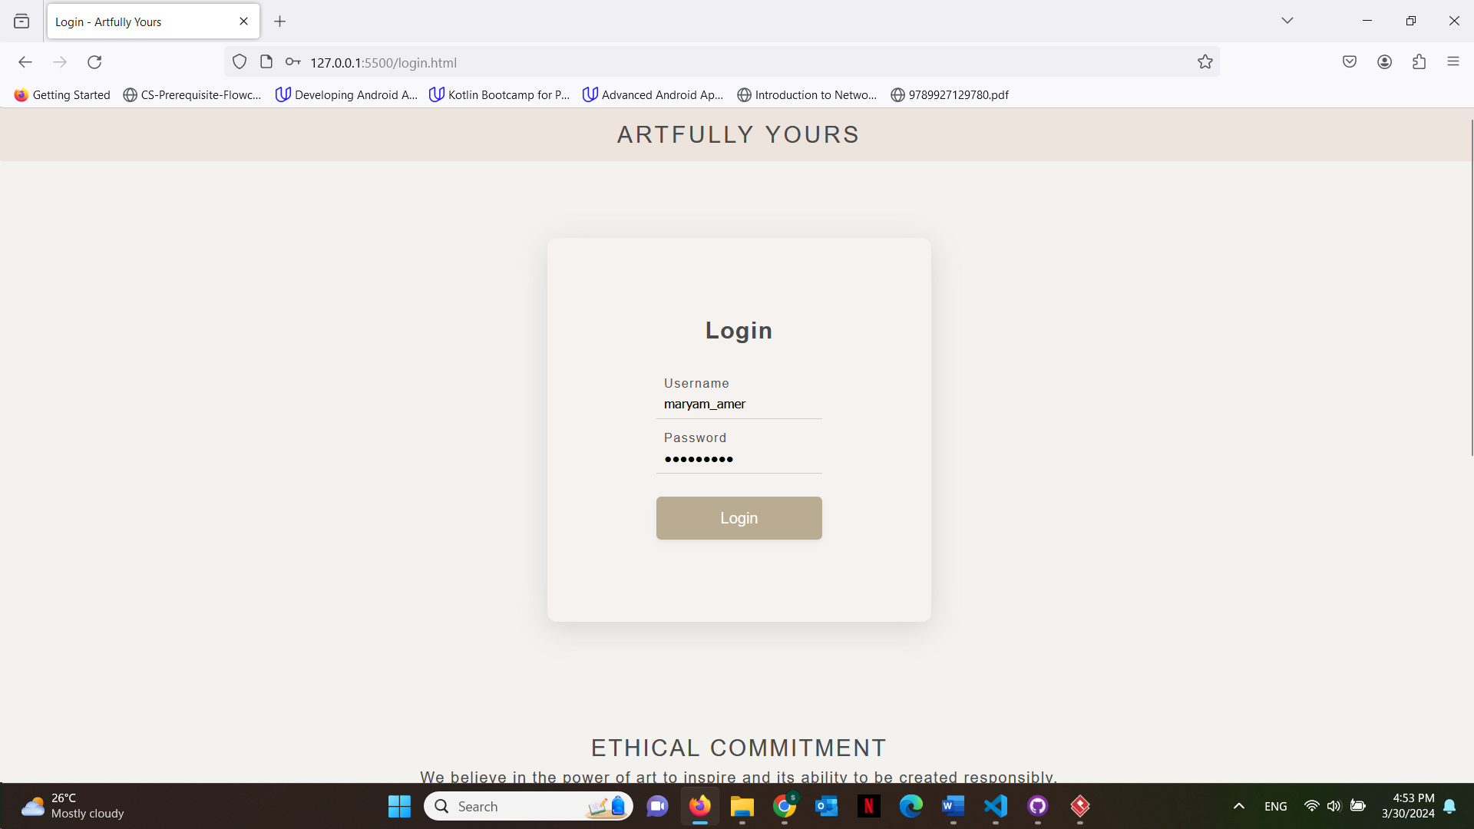

**Admin can choose to change the featured artwork**

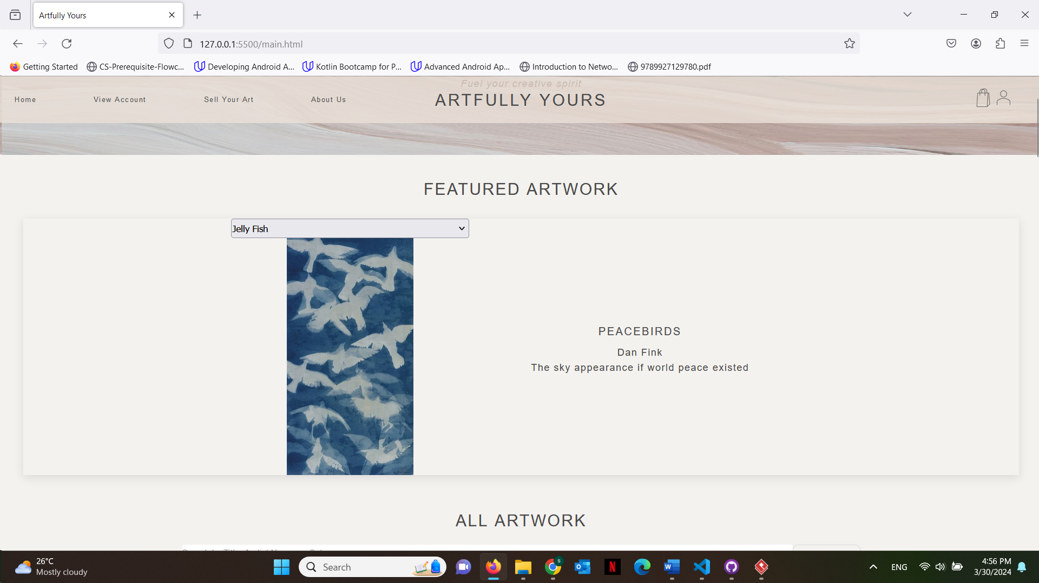

**Admin can also delete current art being sold**

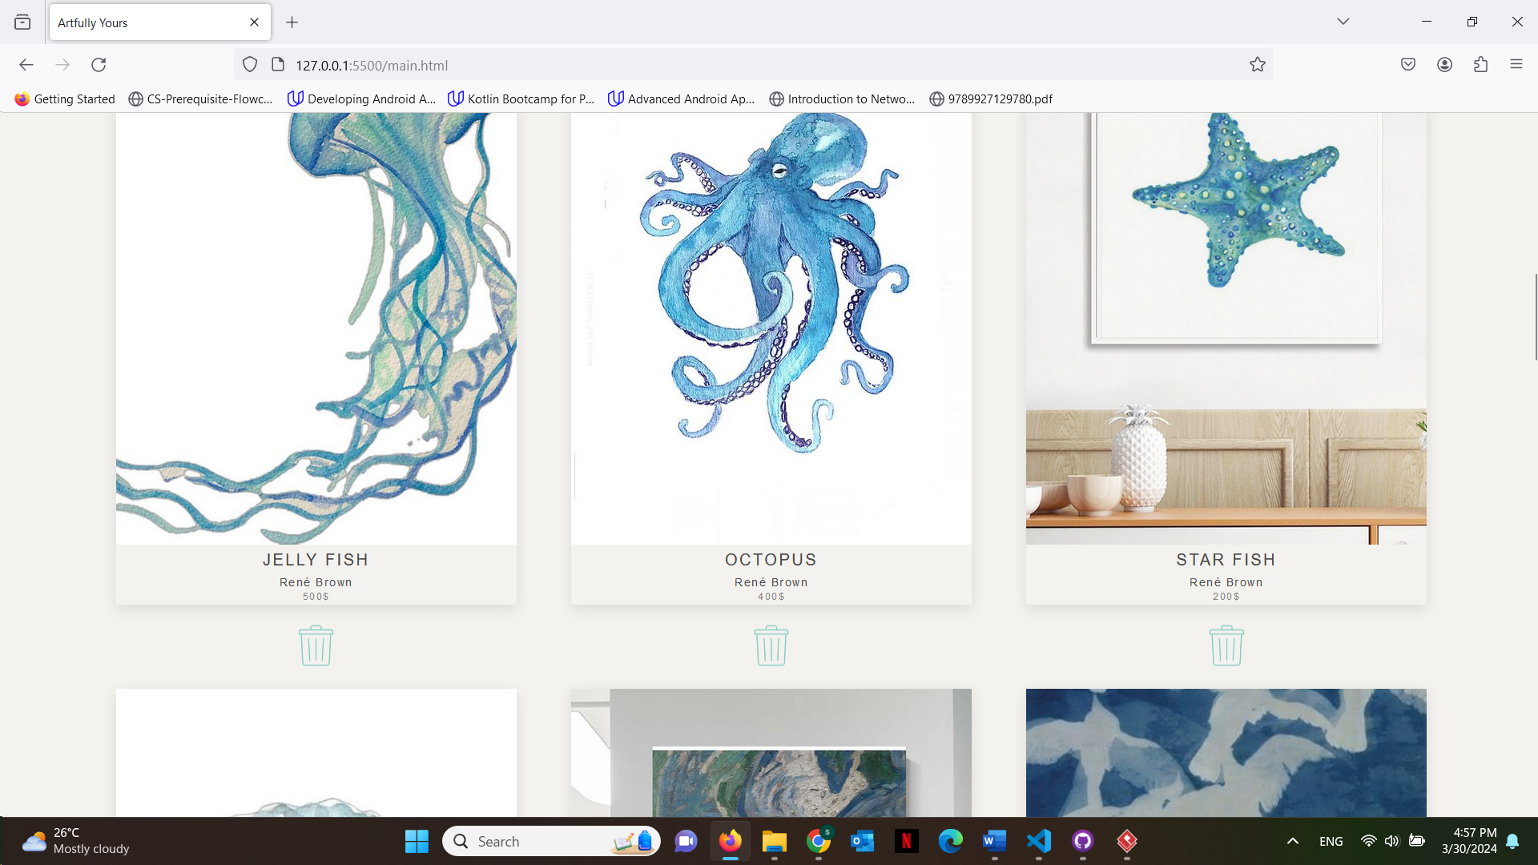

**Now logged in as customer we can see the new featured artwork has changed than the first time** 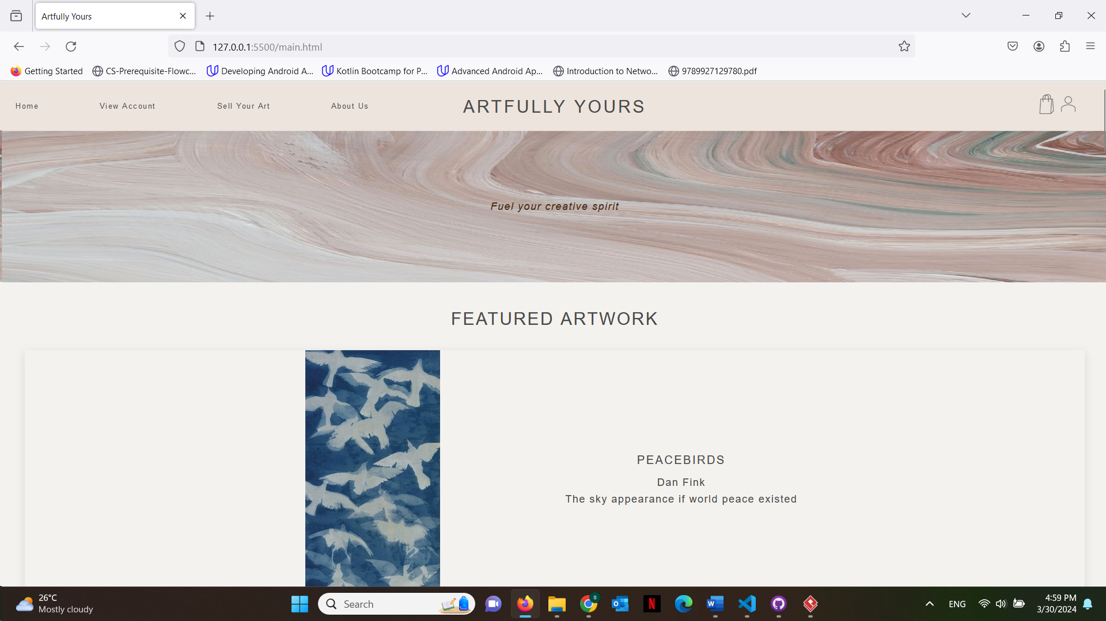

**When customer hovers over a certain artwork, add to cart button shows up and they can press it and get an alert that artwork has been added to their basket**

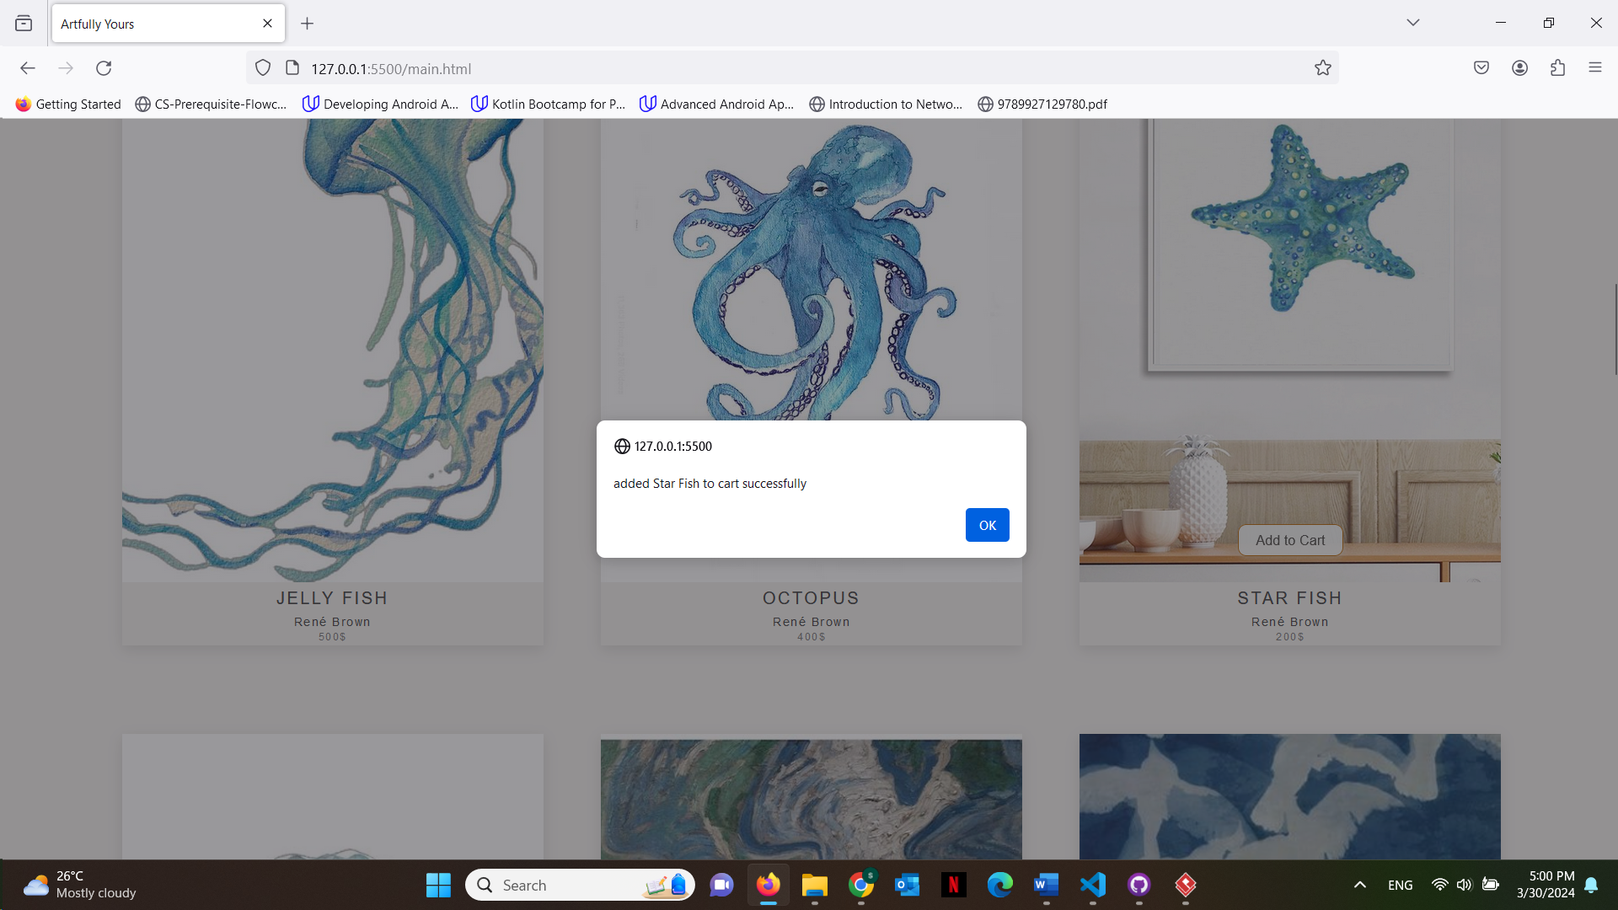

**Customer can check their basket and edit the quantities there**

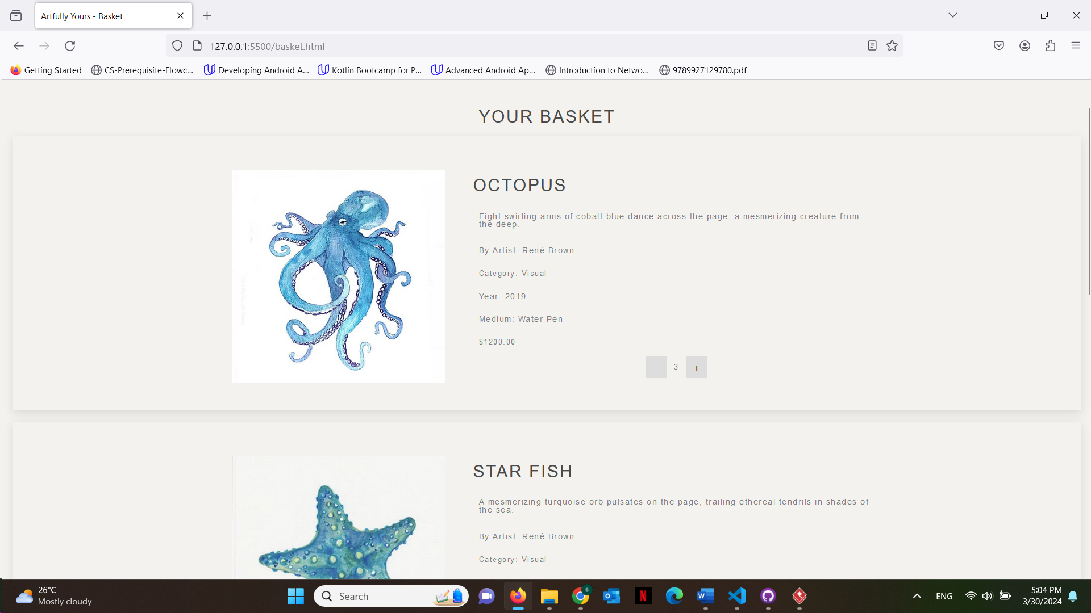

**If they try to buy more than what is available, they get an alert**

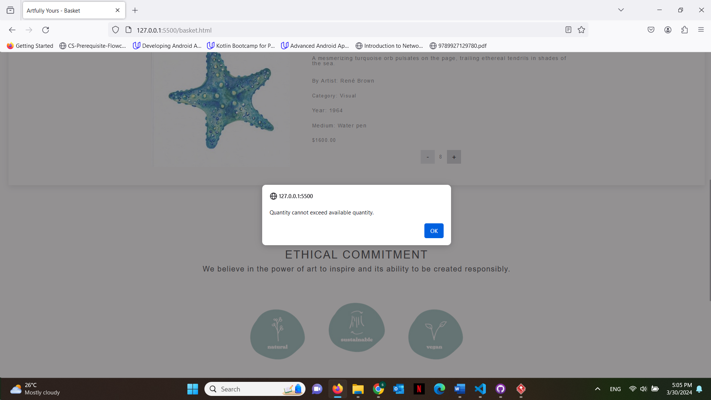

**Once the user presses check out button it will take them to the checkout page to enter their details**

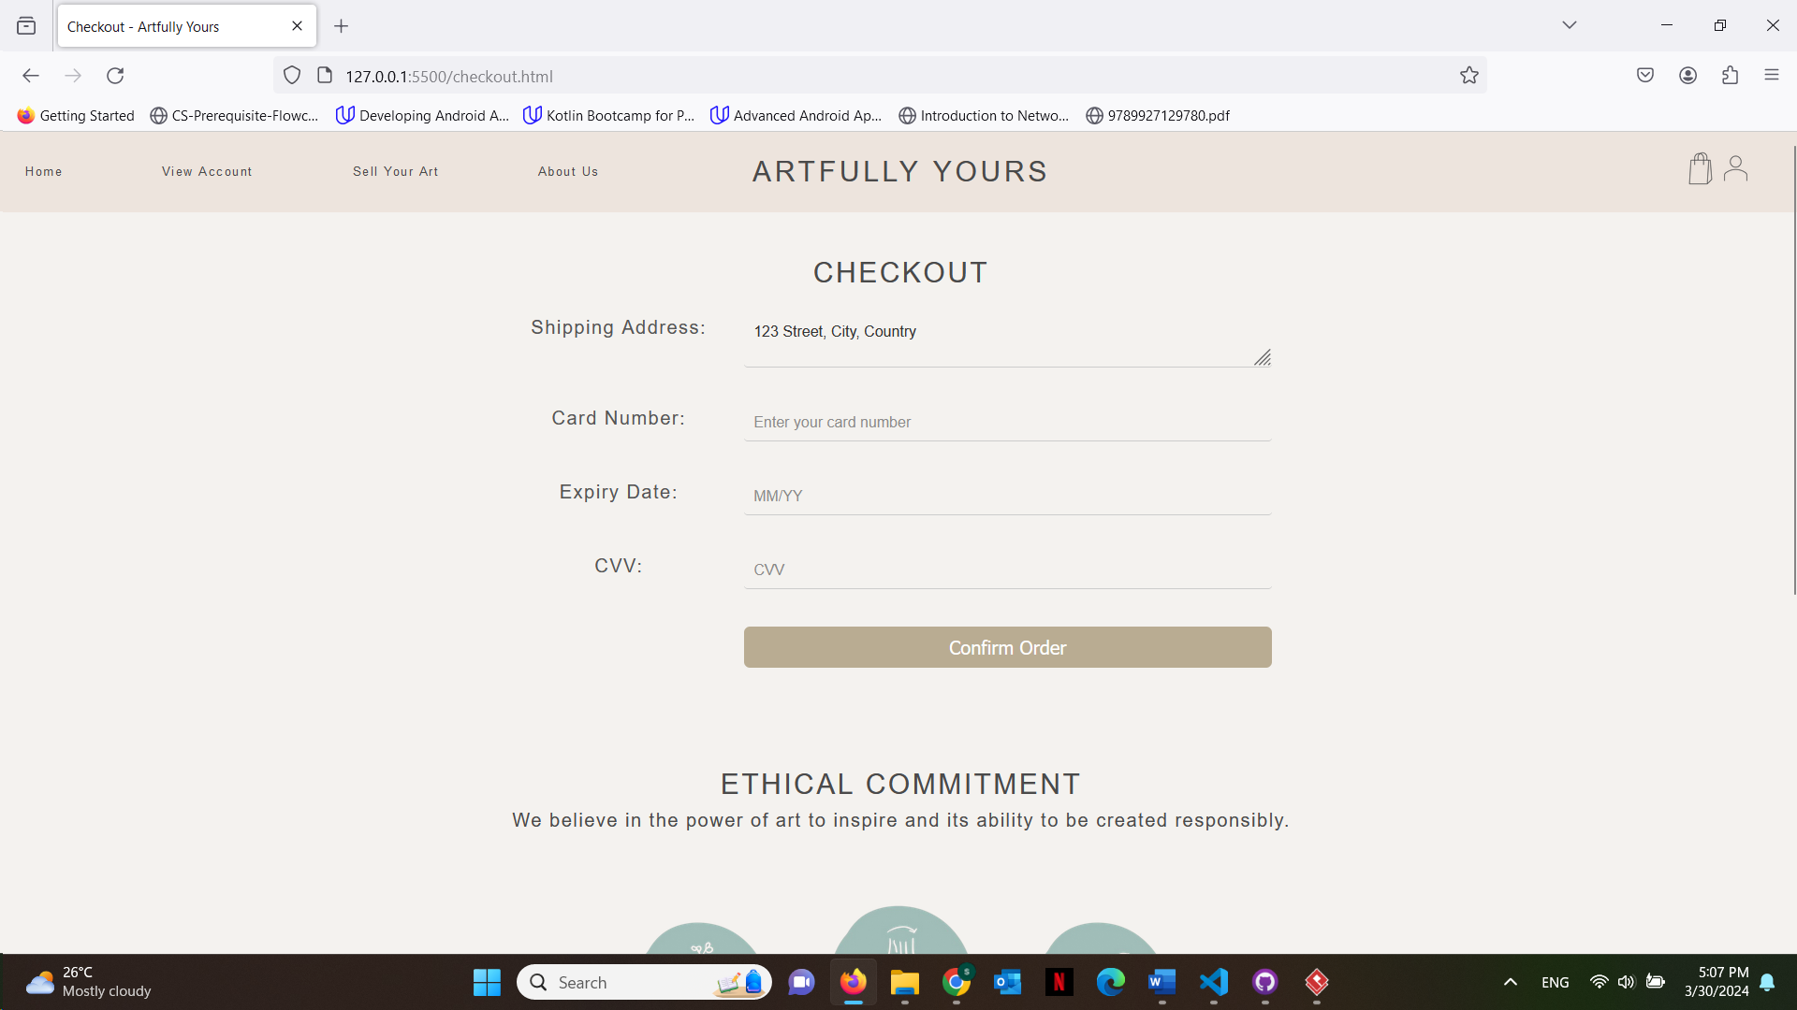

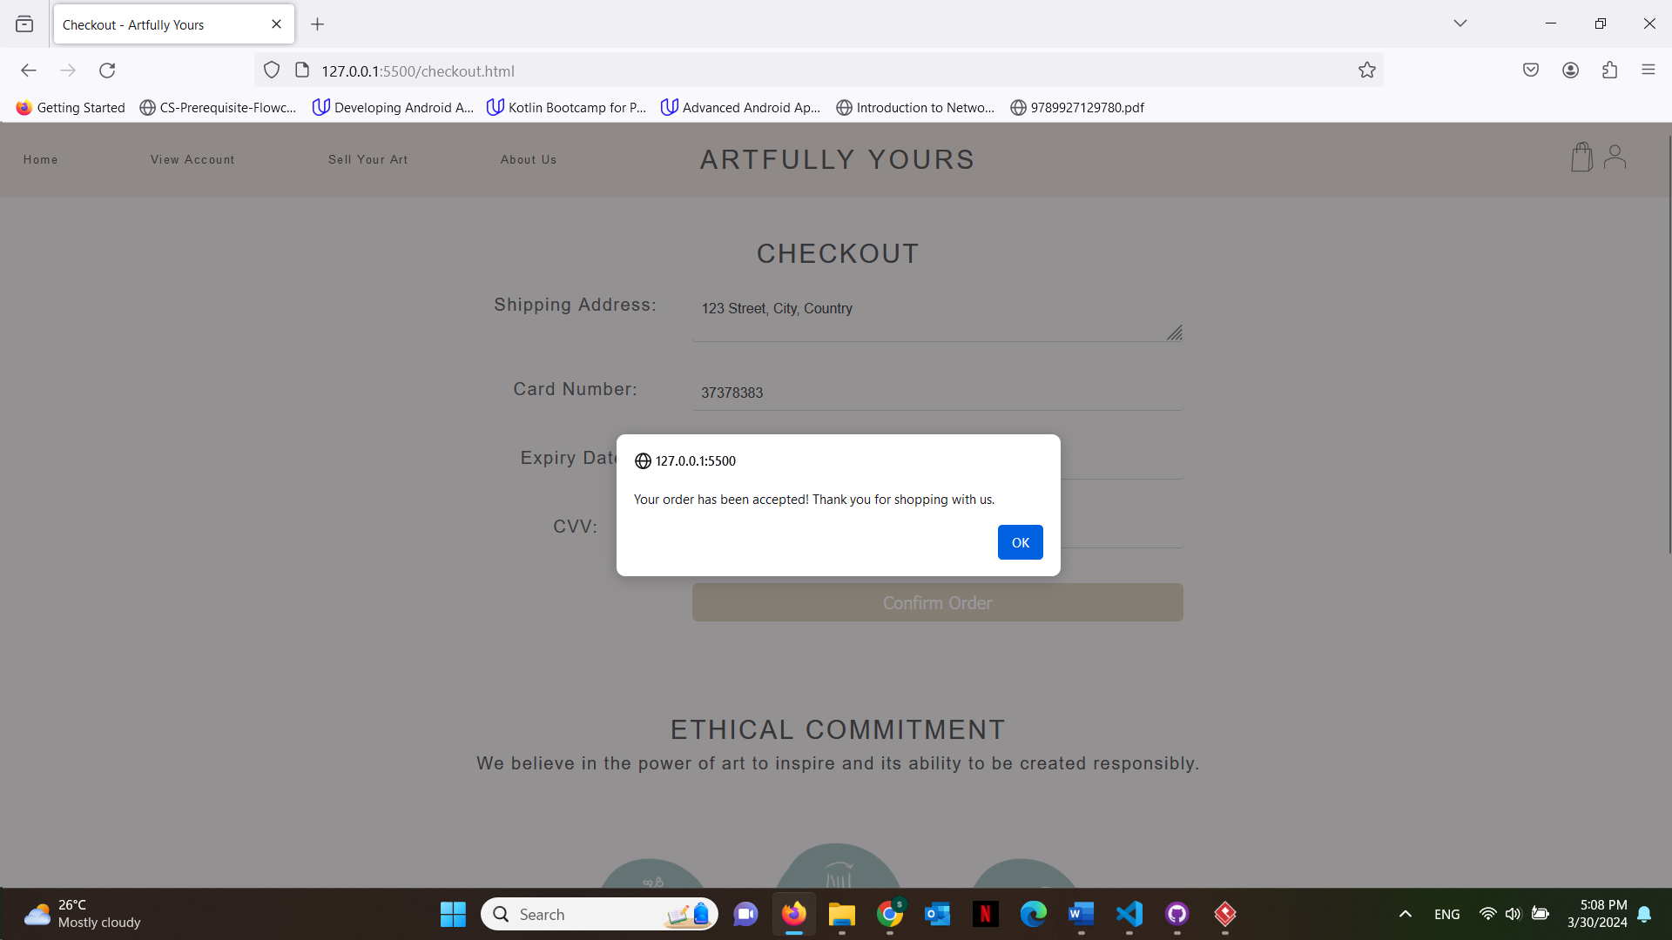

**Now once they go to view account they will see the purchase history**

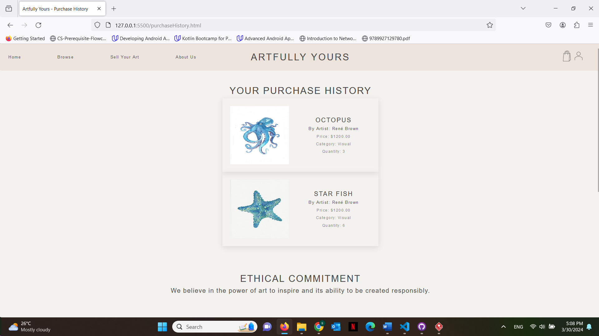

**Trying to buy another artwork**

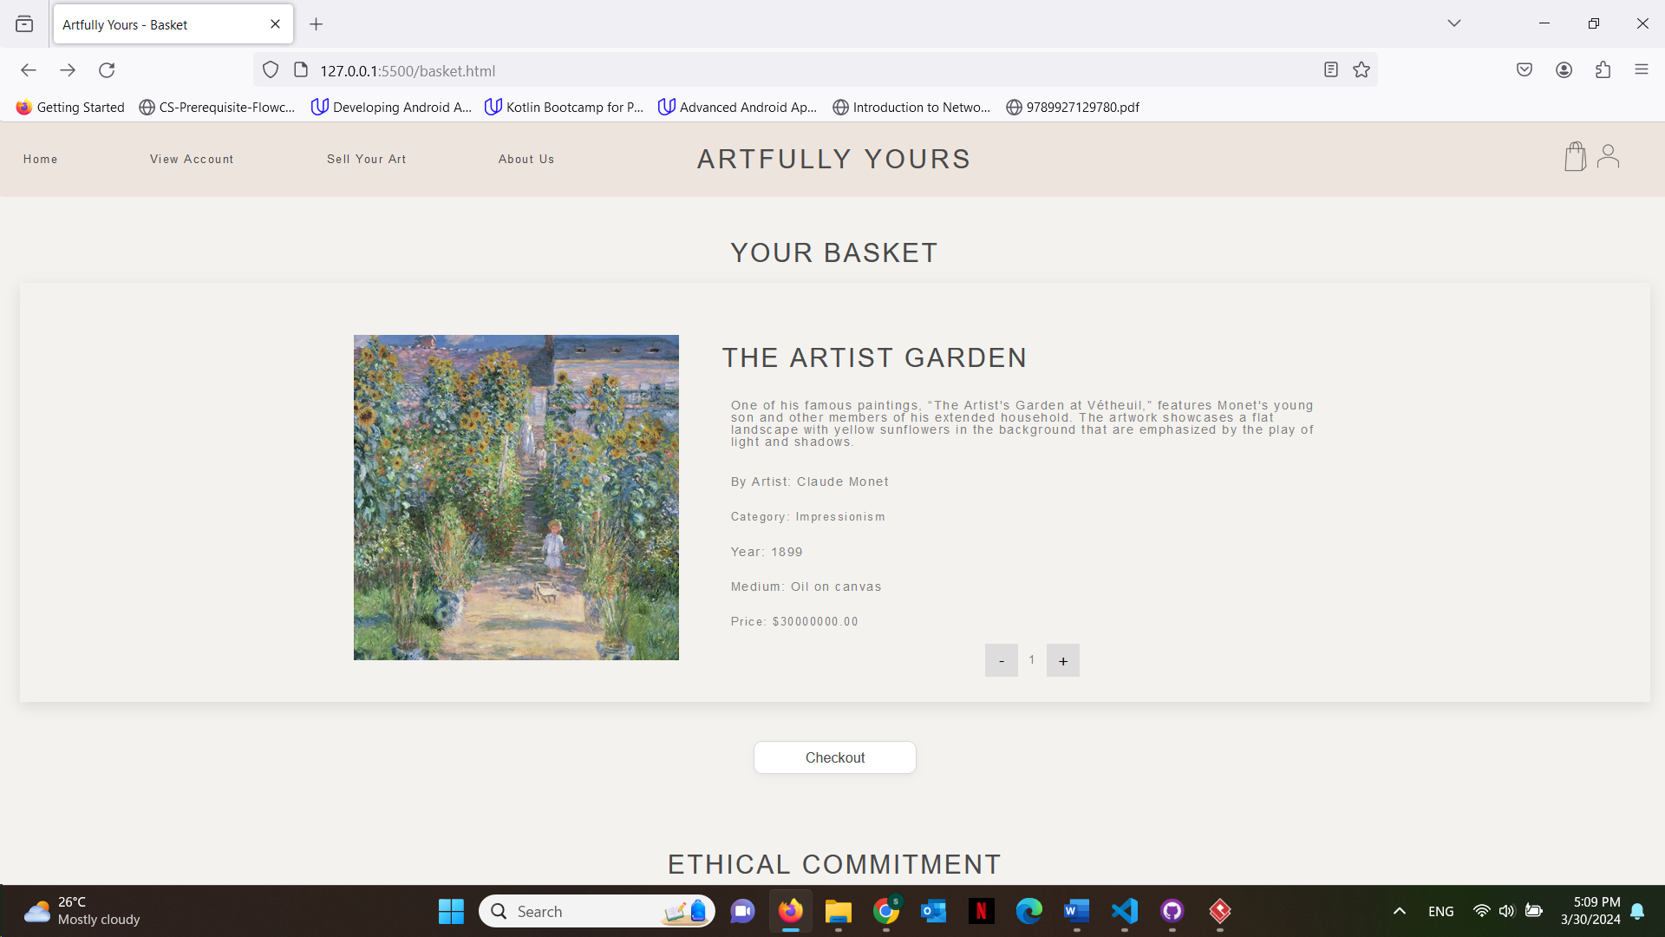

**This time the user details will be displayed already as they got saved**

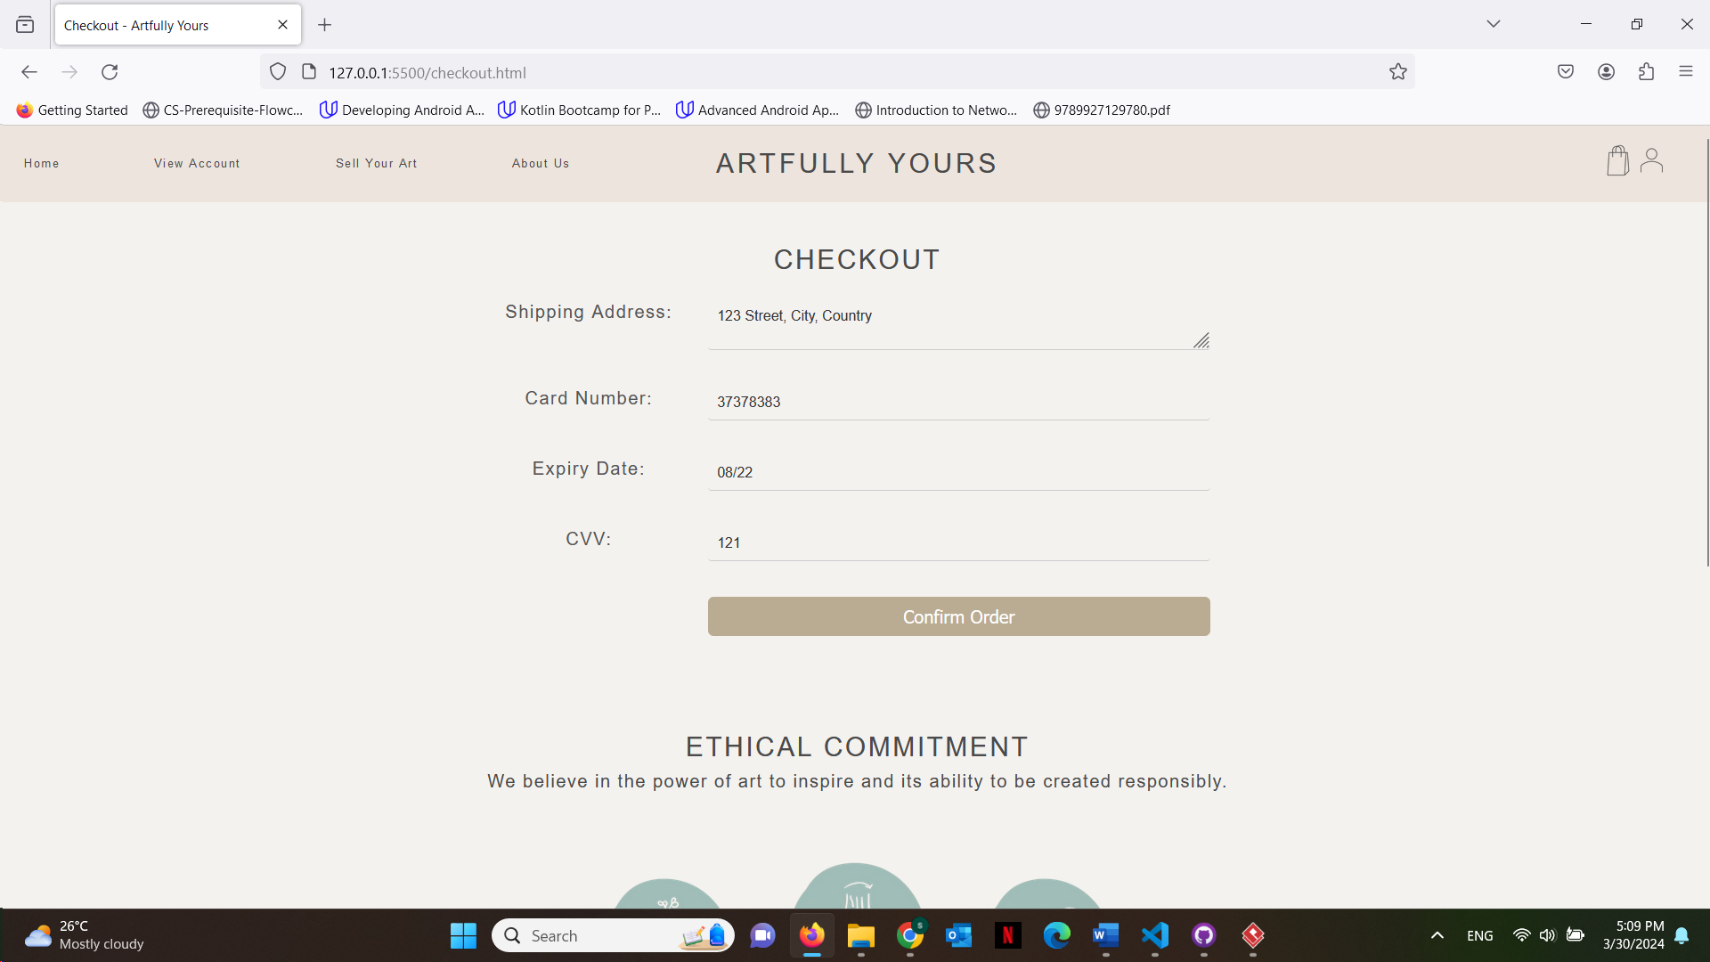

**Once the customer tries to confirm order but they do not have enough balance they get an alert**

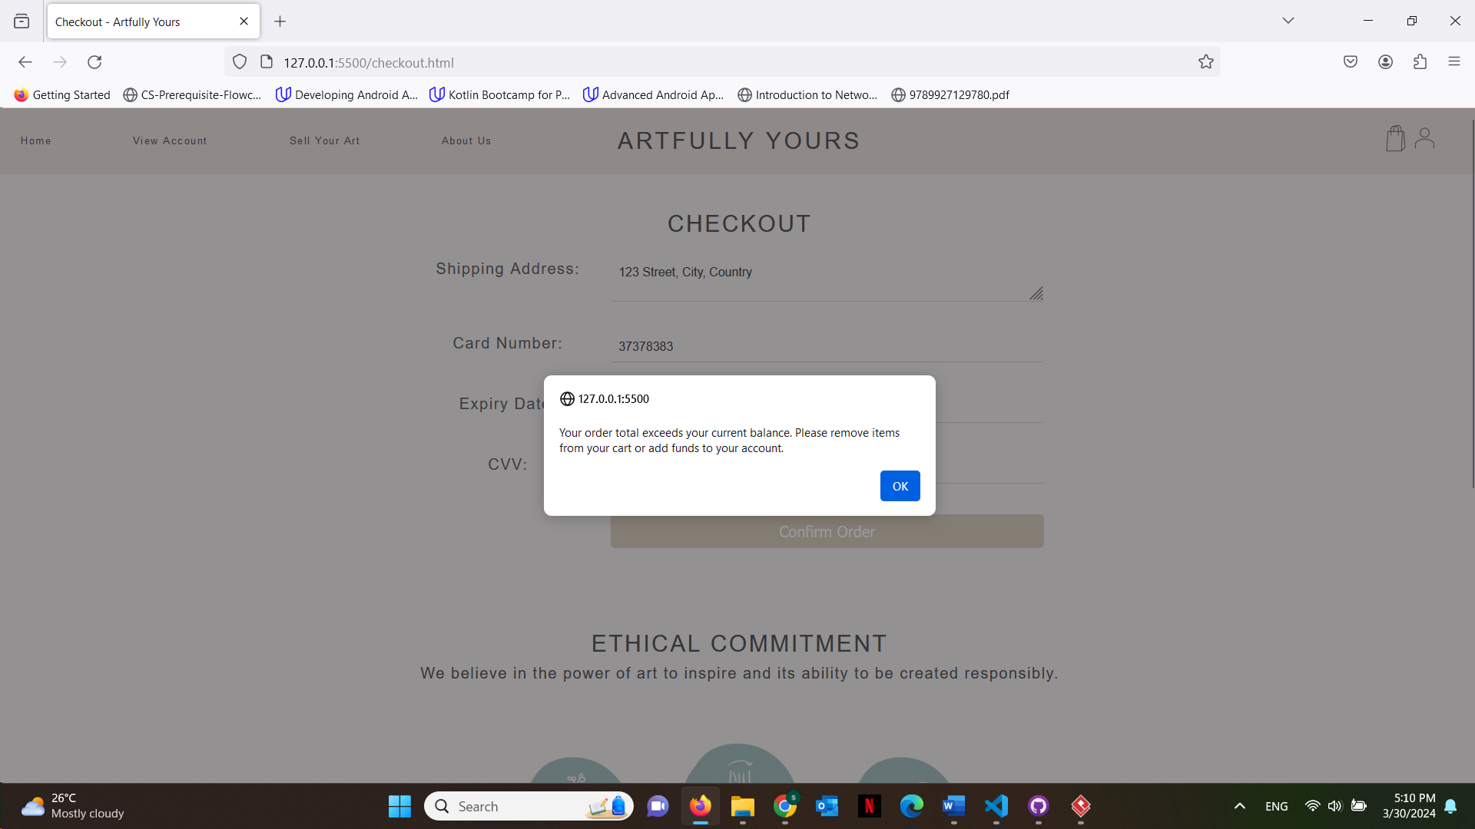

**Every time a user buys an artwork, the artwork quantity decreases so if it reaches 0 and a user tries to add to cart they get an alert**

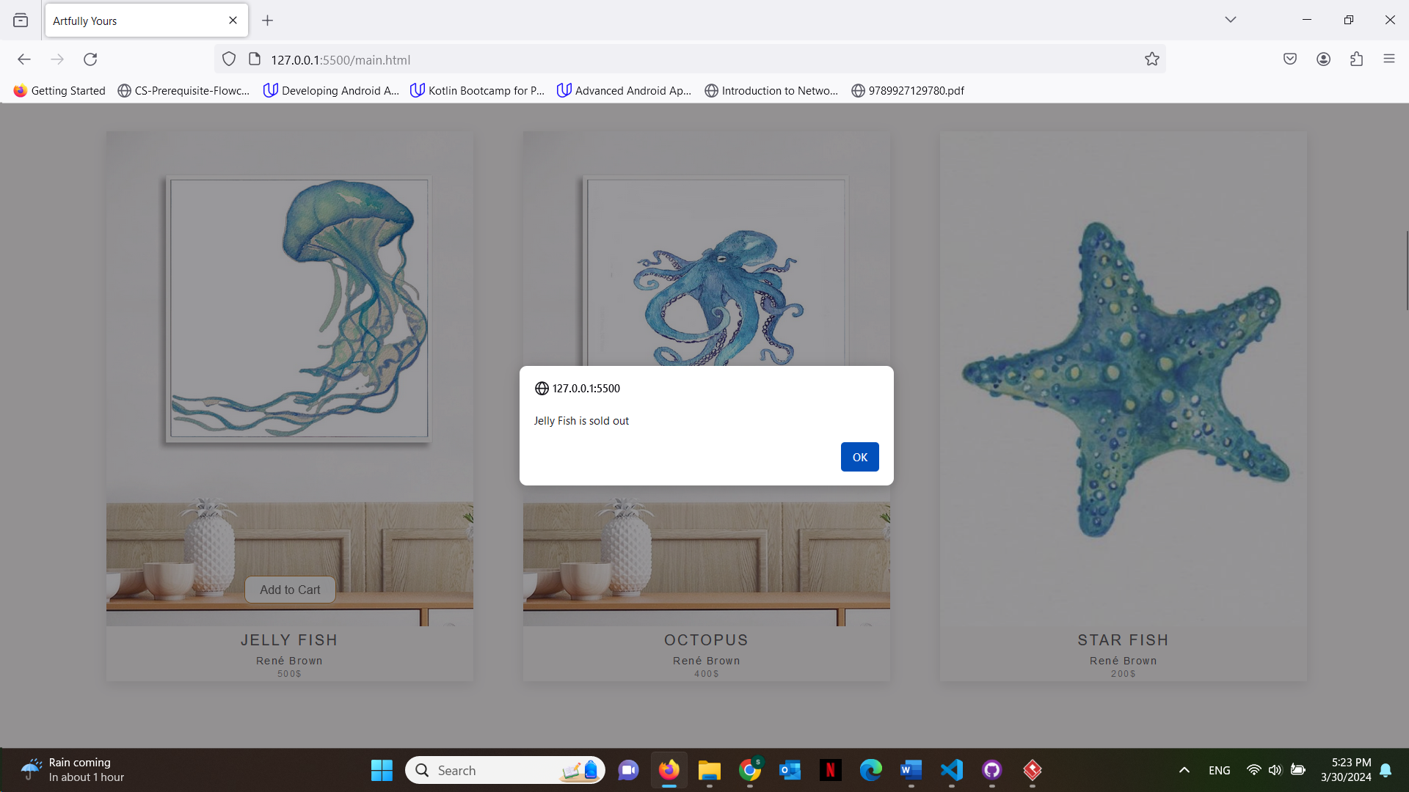

**Now logged in as a seller, once view account is pressed they will be able to see the sale history**

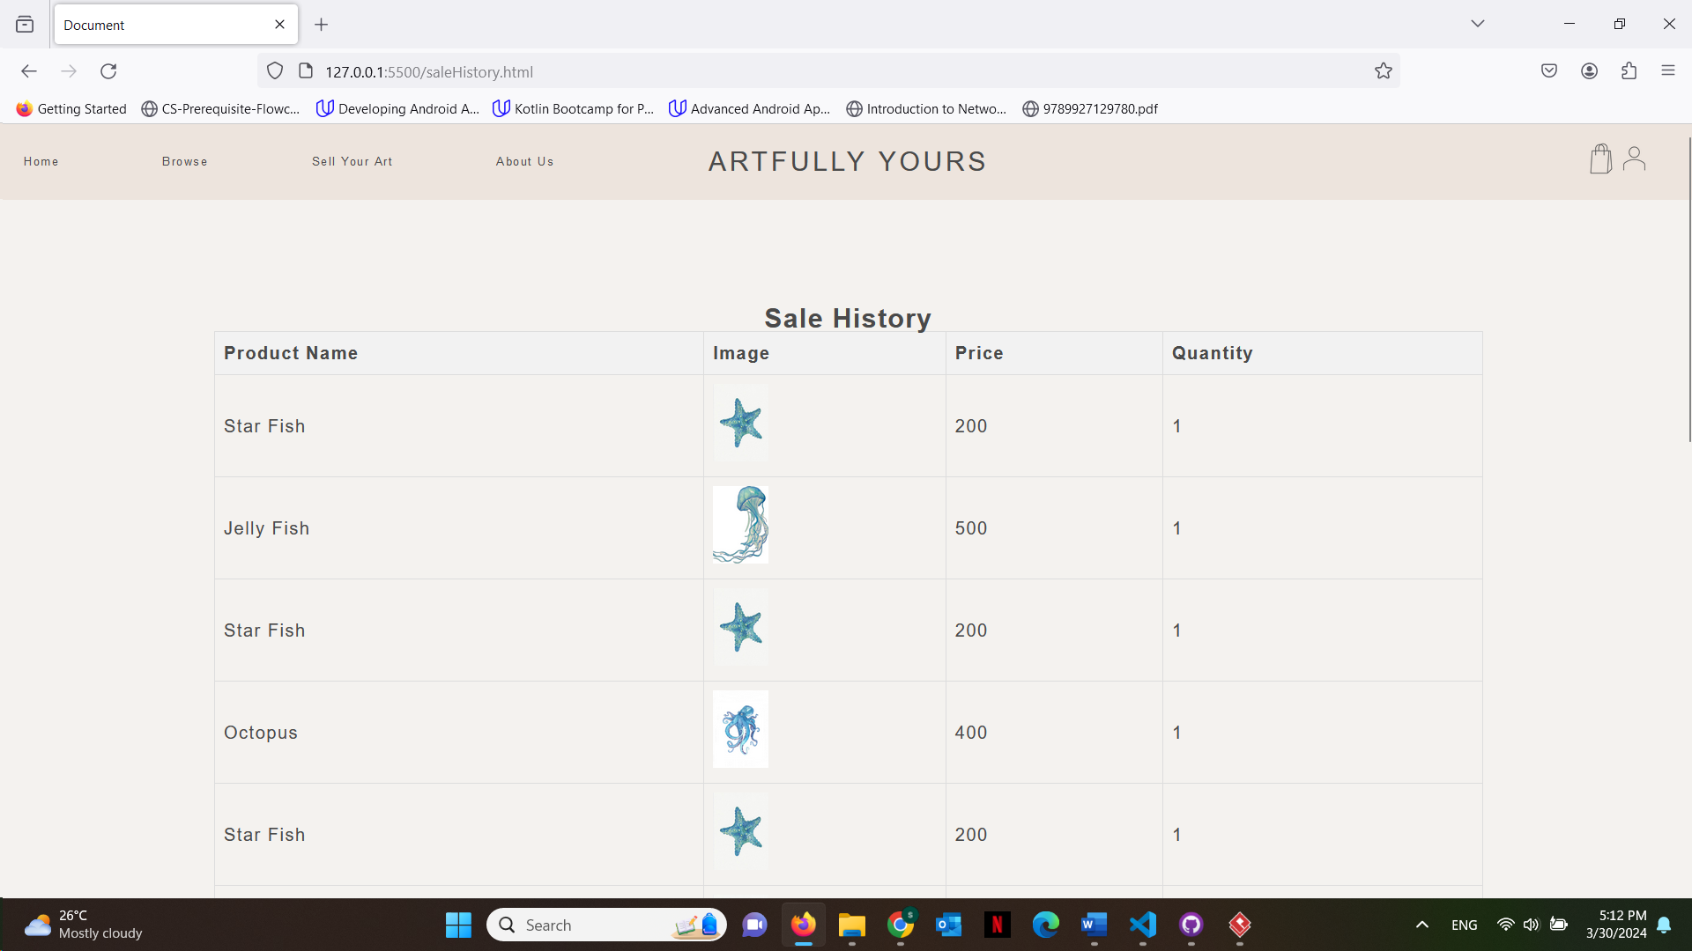

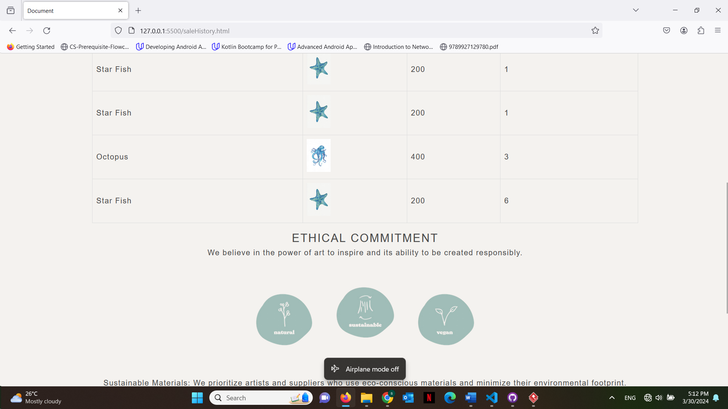

This is what the last customer bought as we just saw.